Instructions on filling out Halo Expense Report Ticket
*Note: Make sure to first gather all the information and materials that you will need. It is not possible to save an in-progress Expense Report Request before submitting it.
- Go to support.ls.wisc.edu/portal/home. Log in if necessary.
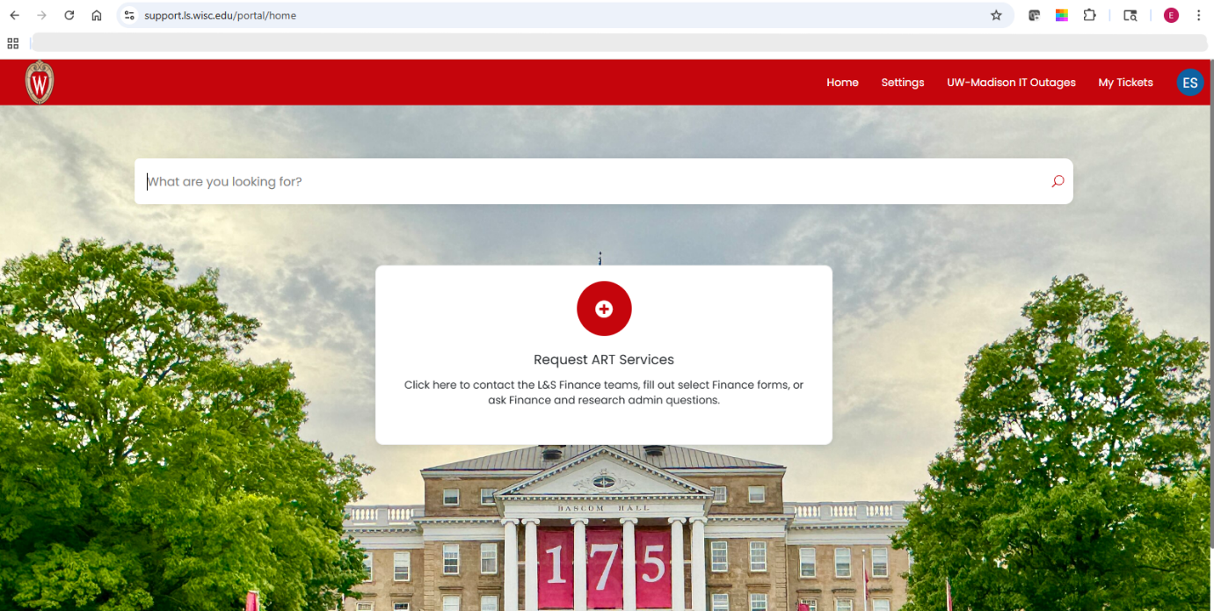
- Click “Request ART Services.”
- Click “Finance forms.”
- Click “Expense Report Requests.”
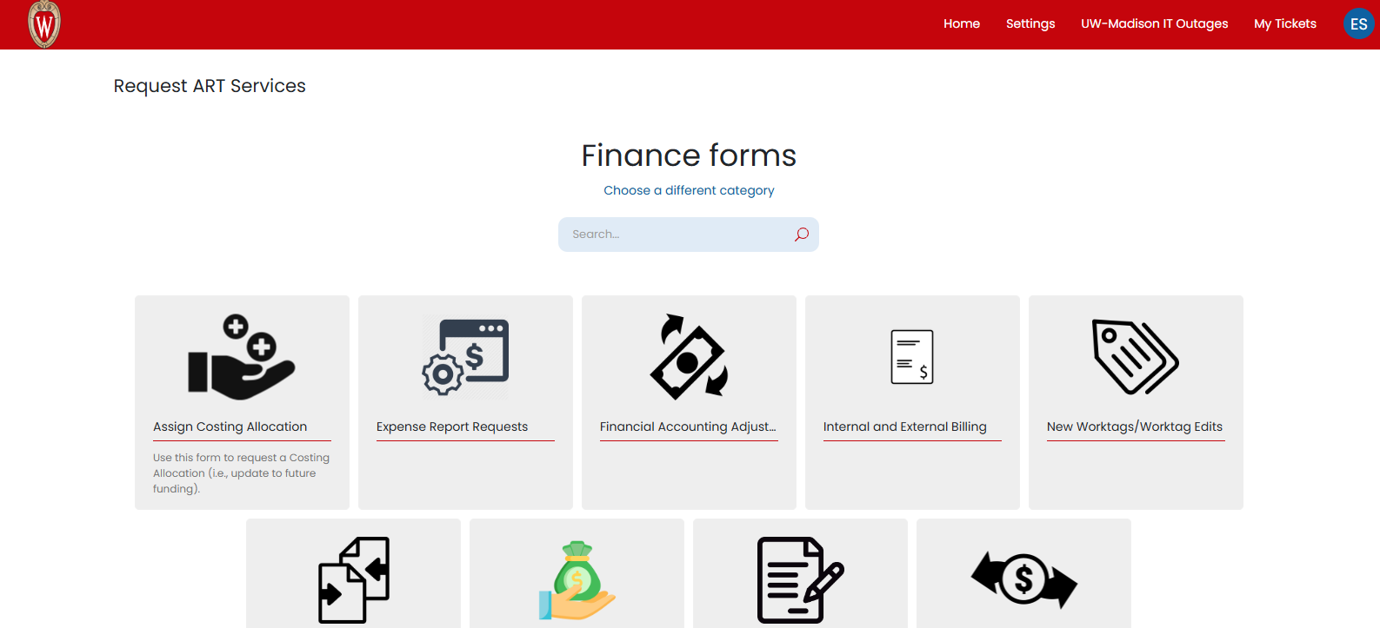
- Fill in the Submitter, Funding, and Business Purpose sections of the form.
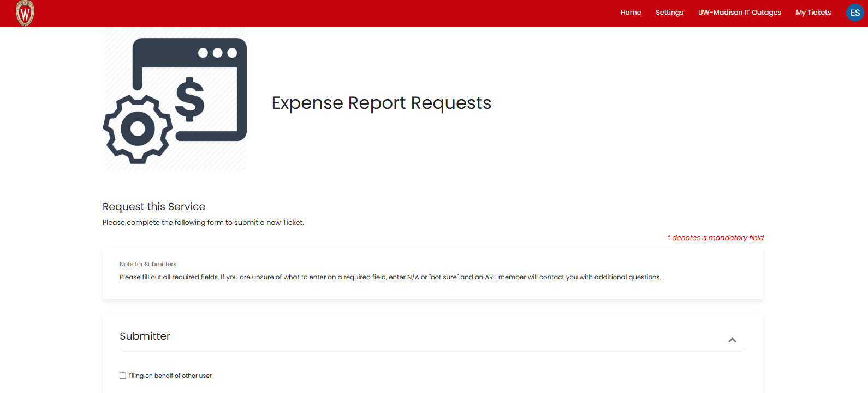
Submitter
Skip this box if you are the person who used the purchased items.
Click the box if you are not the person who used the purchased items.
Funding
Fill out the requested information to the best of your ability. You don’t have to have every detail, but add as much useful information as you can.
Business Purpose
Be specific and descriptive, as if you are justifying the expense/s to someone who has no idea what your work entails.
- Fill in the Travel, Event, and/or Other Expenses sections of the form as needed. You will need to describe each of your individual expenses under one of these three categories.
Travel
Skip this box if (some of) these expenses are not related to work travel.
Click the box if (some of) these expenses are related to work travel.
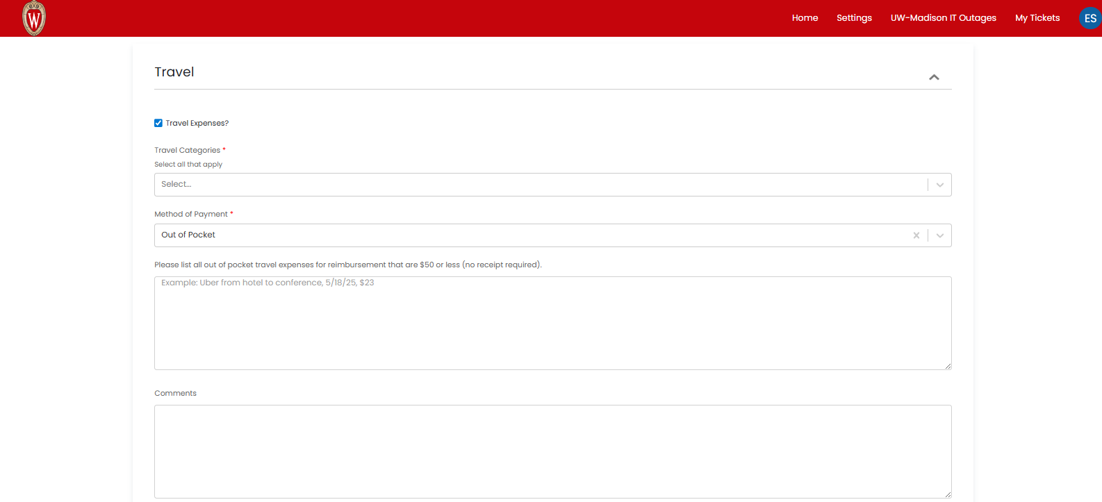
Fill out the requested information to the best of your ability.
Under Travel Categories, select all of the expense types for which you need to be reimbursed for this trip from the drop-down menu.
Under Method of Payment, select “Needs reimbursement” from the drop-down menu.
List all travel expenses, including the date and cost, for items that are $50 or less.
Make sure that you have receipts for any travel expenses over $50 to attach at the end of this form.
Event
Skip this box if (some of) these expenses are not related to a work event.
Click the box if (some of) these expenses are related to a work event.
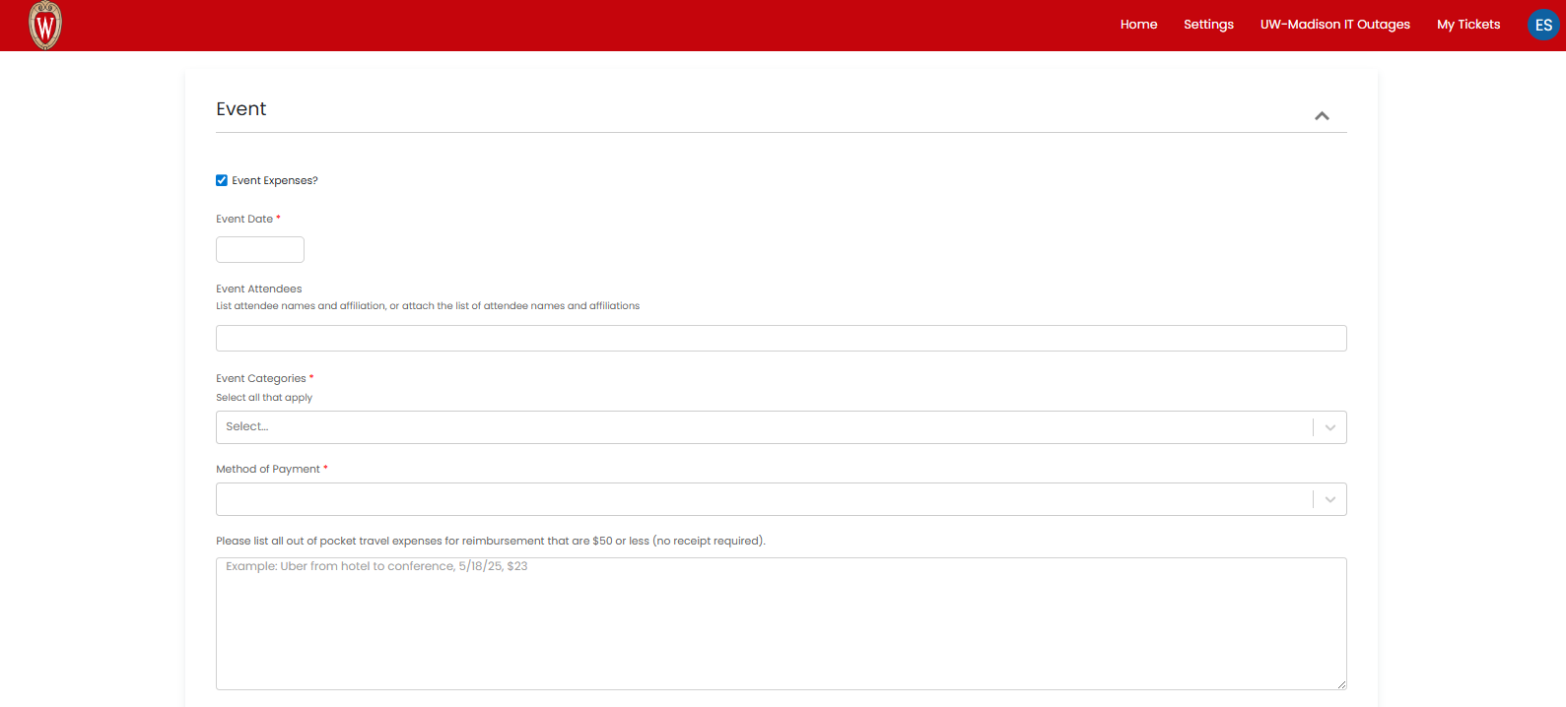
Fill out the requested information to the best of your ability.
Under Event Categories, select all of the expense types for which you need to be reimbursed for this event from the drop-down menu.
Under Method of Payment, select “Needs reimbursement” from the drop-down menu.
List all event expenses, including the date and cost, for items that are $50 or less.
Make sure that you have receipts for any event expenses over $50 to attach at the end of this form.
Other Expenses
Skip this box if you do not have any more expenses that aren’t related to travel or events.
Click the box if you do have more expenses that aren’t related to travel or events. 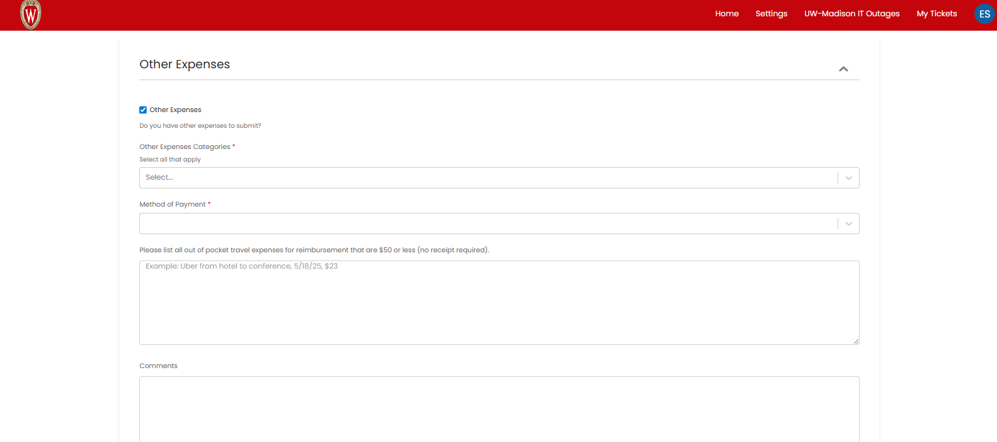
Fill out the requested information to the best of your ability.
Under Other Expenses Categories, select all of the expense types for which you need to be reimbursed for this event from the drop-down menu.
Under Method of Payment, select “Needs reimbursement” from the drop-down menu.
List all expenses, including the date and cost, for items that are $50 or less.
Make sure that you have receipts for any expenses over $50 to attach at the end of this form.
- Fill in the Additional Approver, Outside Funds, and Attachments sections of the form as needed.
Additional Approver
Skip this box unless you are explicitly told to check it and add someone’s email address.
Outside Funds
Skip this box if you do not have funds from an outside source (travel stipend, fellowship, etc.) to support this trip.
Click this box if you do have funds from an outside source (travel stipend, fellowship, etc.) to support this trip.
Attachments
Attach all required receipts and documents, including:
- Receipts for all expenses over $50.
- Airfare and hotel information, if applicable.
- Event agenda, if applicable.

- Click Submit.

What happens next?
Your form will be sent to our Financial ART specialists, who will review it for accuracy and will be in touch with you if they need more information or clarification.

